ANSWERS : 1 , 2 , 3 , 4

ANSWER : 5 , 6

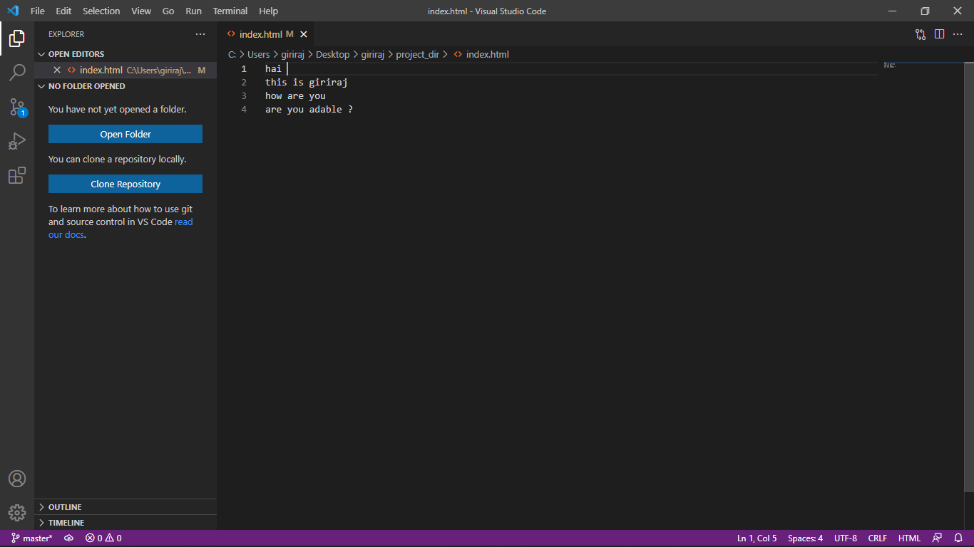

ANSWER 7

ANSWER 7 , 8, 9,

ANSWER 10, 11 ,12

ANSWER 13

ANSWER : 14 : $git checkout -- .

ANSWER : 15

ANSWER : 16,17,18,19,20

ANSWER 21 IS ABOVE PAGE.

ANSWER : 22 23

ANSWER 23

ANSWER 24, 25, 26

ANSWER : 27

ANSWER 29 ( make minor changes on html files)

ANSWER 30 AND 31

ANSWER 32 :

giriraj@LAPTOP-KCODOE77 MINGW64 ~/Desktop/giriraj/project_dir/assignments (master)

$ git my-add .

giriraj@LAPTOP-KCODOE77 MINGW64 ~/Desktop/giriraj/project_dir/assignments (master)

$ git commit -m "minor changes on readme file"[master 49f0011] minor changes on readme file

1 file changed, 2 insertions(+), 2 deletions(-)

ANSWER 33.

giriraj@LAPTOP-KCODOE77 MINGW64 ~/Desktop/giriraj/project_dir/assignments (mast

$ git checkout html-assignments

Switched to branch 'html-assignments'

ANSWER 34 (Minor changes on html files)

ANSWER 35:

giriraj@LAPTOP-KCODOE77 MINGW64 ~/Desktop/giriraj/project_dir/assignments (html-assignments)

$ git my-add .

giriraj@LAPTOP-KCODOE77 MINGW64 ~/Desktop/giriraj/project_dir/assignments (html-assignments)

$ git commit -m "minor changes on html files"

[html-assignments 7dd1095] minor changes on html files

2 files changed, 1 insertion(+), 2 deletions(-)

ANSWER 36

ANSWER 37 :

giriraj@LAPTOP-KCODOE77 MINGW64 ~/Desktop/giriraj/project_dir/assignments (html-assignments)

$ git merge html-assignments

Merge made by the &#39;recursive&#39; strategy.

index1.html | 10 ++++++++++

1 file changed, 10 insertions(+)

create mode 100644 Anime.html

ANSWER 38:

giriraj@LAPTOP-KCODOE77 MINGW64 ~/Desktop/giriraj/project_dir/assignments (html-assignments)

$ git branch -D html-assignments

Deleted branch html-assignments (was 7dd1095).

SECTION-2 – (CSS ASSIGNMENTS)

ANSWER 1:

giriraj@LAPTOP-KCODOE77 MINGW64 ~/Desktop/giriraj/project_dir/assignments (master|MERGING)

$ git branch css-assignments

ANSWER-2:

giriraj@LAPTOP-KCODOE77 MINGW64 ~/Desktop/giriraj/project_dir/assignments (master|MERGING)

$ git checkout css-assignments

Switched to branch 'css-assignments'

A assignments/index1.html

A assignments/index2.html

A assignments/index3.html

ANSWER 3

giriraj@LAPTOP-KCODOE77 MINGW64 ~/Desktop/giriraj/project_dir/assignments (css-assignments)

$ touch a.css

giriraj@LAPTOP-KCODOE77 MINGW64 ~/Desktop/giriraj/project_dir/assignments (css-assignments)

$ touch b.css

ANSWER 4

giriraj@LAPTOP-KCODOE77 MINGW64 ~/Desktop/giriraj/project_dir/assignments (css-assignments)

$ git my-add .

giriraj@LAPTOP-KCODOE77 MINGW64 ~/Desktop/giriraj/project_dir/assignments (css-assignments)

$ git commit -m "initial commit "

[css-assignments 518c2bf] initial commit

5 files changed, 4 insertions(+)

create mode 100644 assignments/a.css

create mode 100644 assignments/b.css

create mode 100644 assignments/index1.html

create mode 100644 assignments/index2.html

create mode 100644 assignments/index3.html

giriraj@LAPTOP-KCODOE77 MINGW64 ~/Desktop/giriraj/project_dir/assignments (css-assignments)

$ ls

README.txt a.css b.css index1.html index2.html index3.html

ANSWER 5:

Minor changes are done in README.txt od css-assignments

ANSWER 6:

giriraj@LAPTOP-KCODOE77 MINGW64 ~/Desktop/giriraj/project_dir/assignments (css-assignments)

$ git commit -m "MINOR commit IN README"

[css-assignments 0707ea4] MINOR commit IN README

1 file changed, 2 insertions(+), 2 deletions(-)

ANSWER 7:

giriraj@LAPTOP-KCODOE77 MINGW64 ~/Desktop/giriraj/project_dir/assignments (css-assignments)

$ git checkout master

Switched to branch 'master'

ANSWER 8:

giriraj@LAPTOP-KCODOE77 MINGW64 ~/Desktop/giriraj/project_dir/assignments (master)

$ git commit -m "line3 change IN README"

[master 785cfd8] line3 change IN README

1 file changed, 1 insertion(+)

ANSWER 9:

giriraj@LAPTOP-KCODOE77 MINGW64 ~/Desktop/giriraj/project_dir/assignments (master)

$ git checkout css-assignments

Switched to branch 'css-assignments'

ANSWER 10:

CHANGES ARE DONE

ANSWER 11:

giriraj@LAPTOP-KCODOE77 MINGW64 ~/Desktop/giriraj/project_dir/assignments (css-assignments)

$ git commit -m "line76786 change IN README file"

[css-assignments d4dc01d] line76786 change IN README file

2 files changed, 3 insertions(+), 2 deletions(-)

ANSWER 12:

giriraj@LAPTOP-KCODOE77 MINGW64 ~/Desktop/giriraj/project_dir/assignments (css-assignments)

$ git checkout master

Switched to branch 'master'

ANSWER 13:

giriraj@LAPTOP-KCODOE77 MINGW64 ~/Desktop/giriraj/project_dir/assignments (master)

$ git merge css-assignments

Already up to date

ANSWER 14:

giriraj@LAPTOP-KCODOE77 MINGW64 ~/Desktop/giriraj/project_dir/assignments (master|MERGING)

$ git branch -D css-assignments

Deleted branch css-assignments (was d4dc01d).

SECTION 3:---

ANSWER 1:

giriraj@LAPTOP-KCODOE77 MINGW64 ~/Desktop/giriraj/project_dir/assignments (master)

$ git branch js-assignments

ANSWER 2:

giriraj@LAPTOP-KCODOE77 MINGW64 ~/Desktop/giriraj/project_dir/assignments (master)

$ git checkout js-assignments

Switched to branch 'js-assignments'

M index1.html

ANSWER 3, 4:

giriraj@LAPTOP-KCODOE77 MINGW64 ~/Desktop/giriraj/project_dir/assignments (js-assignments)

$ git add .

giriraj@LAPTOP-KCODOE77 MINGW64 ~/Desktop/giriraj/project_dir/assignments (js-assignments)

$ git commit -m "initial commit in branch"

[js-assignments 231a4dd] initial commit in branch

2 files changed, 3 insertions(+), 2 deletions(-)

create mode 109876 jsFile.txt

ANSWER 5 , 6:

giriraj@LAPTOP-KCODOE77 MINGW64 ~/Desktop/giriraj/project_dir/assignments (js-assignments)

$ git add .

giriraj@LAPTOP-KCODOE77 MINGW64 ~/Desktop/giriraj/project_dir/assignments (js-assignments)

$ git commit -m "committed changes in readme of branch"

[js-assignments 5238742] committed changes in readme of branch

1 file changed, 1 insertion(+), 1 deletion(-)

ANSWER 7:

giriraj@LAPTOP-KCODOE77 MINGW64 ~/Desktop/giriraj/project_dir/assignments (js- assignments)

$ git checkout master

Switched to branch 'master'

ANSWER 8:

giriraj@LAPTOP-KCODOE77 MINGW64 ~/Desktop/giriraj/project_dir/assignments (master)

$ git add .

giriraj@LAPTOP-KCODOE77 MINGW64 ~/Desktop/giriraj/project_dir/assignments (master)

$ git commit -m "committed changes in readme of master"

[master 40g8es] committed changes in readme of master

1 file changed, 1 insertion(+), 1 deletion(-)

ANSWER 9:

giriraj@LAPTOP-KCODOE77 MINGW64 ~/Desktop/giriraj/project_dir/assignments (master)

$ git checkout js-assignments

Switched to branch 'js-assignments'

ANSWER 10, 11:

giriraj@LAPTOP-KCODOE77 MINGW64 ~/Desktop/giriraj/project_dir/assignments (js-assignments)

$ git add .

giriraj@LAPTOP-KCODOE77 MINGW64 ~/Desktop/giriraj/project_dir/assignments (js-assignments)

$ git commit -m "commit changes in js file of branch"

[js-assignments 588d293] commit changes in js file of branch

1 file changed, 2 insertions(+), 1 deletion(-)

ANSWER 12:

giriraj@LAPTOP-KCODOE77 MINGW64 ~/Desktop/giriraj/project_dir/assignments (master)

$ git checkout master

Switched to branch 'master'

ANSWER 13:

giriraj@LAPTOP-KCODOE77 MINGW64 ~/Desktop/giriraj/project_dir/assignments (master|MERGING)

$ git merge js-assignments

Auto-merging README.txt

CONFLICT (content): Merge conflict in README.txt

Automatic merge failed; fix conflicts and then commit the result.

giriraj@LAPTOP-KCODOE77 MINGW64 ~/Desktop/giriraj/project_dir/assignments (master|MERGING)

$ git add .

giriraj@LAPTOP-KCODOE77 MINGW64 ~/Desktop/giriraj/project_dir/assignments (master|MERGING)

$ git commit -m "commit manually resolve merge"

[master d74f5cb] commit manually resolve merge

giriraj@LAPTOP-KCODOE77 MINGW64 ~/Desktop/giriraj/project_dir/assignments (master)

$ git merge js-assignments

Already up to date.

ANSWER 14:

giriraj@LAPTOP-KCODOE77 MINGW64 ~/Desktop/giriraj/project_dir/assignments (master)

$ git branch -D js-assignments

Deleted branch js-assignments (was 345d65).